This website allows you to go online 24/7 and view all of your accounts with us in one place. It gives you information about the current values (Holdings by Investor) report and past performance (Comparative Holdings by Investor) report.
To register for the website, you can visit: https://lpl.mainaccount.com/
We recommend that you immediately save this log-in screen to your browser favorites so that you don’t have to look it up again.
First, click on the "Registration" button on the login screen and the following will appear:
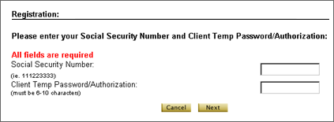
At the Registration page, enter your Social Security number, with *no* dashes or spaces between numbers.
Then, enter the Client Temp Password that Brad or Samantha provided to you. If you have not been provided with the temporary password, please email us at brad@integrigenwealth.com or samantha@integrigenwealth.com or feel free to give us a call at 301-251-1005.
Hit the "Next" button to submit this form. Next, review the User Agreement, and hit the "Accept" button to proceed to the next step.
At Registration Process: Step 1 of 2, set your Username and Password. Each can be any combination of capital and lower case letters and/or numbers, but should contain no spaces and must be at least 10 characters total. Choose a username and password which are easy to remember, but which are not so obvious that they can be easily guessed (e.g. your initials). It's a good idea to write them both down somewhere, in case you forget them later.
Please enter all the required fields of your personal information. The information that you entered will be secure and protected from third party viewing. Please make sure to accurately enter your information. The information will allow us to forward you printed and/or e-mail statements. It will also help you retrieve a lost or forgotten password. You will need your username to request the "forgot password" tool. Then, the system will immediately send your password to your e-mail account.
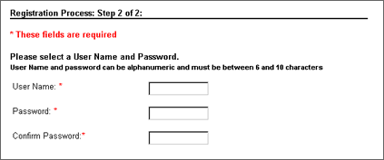
After you complete the registration process, we will receive an Investor Registration Notification e-mail. This e-mail will inform us that you have been successfully registered and that you are requesting immediate activation. We will approve you as soon as possible and an Approval Notification e-mail will be automatically sent to inform you that your logon is now active.
When you log in for the first time, you will see the “Combined Account Portfolio” Holdings by Investor Report. Please understand that the accounts displayed are only your combined accounts at all of the various custodians/financial institutions, (Pershing, LPL, Annuity Companies, etc) of which we are the rep of record for you. Please note that if you are married or have another investor in your household, you have to change the report from the “Combined Account Portfolio” to include this other individual. To do so, you click on the drop down arrow to the right of “Combined Account Portfolio.” There should be another portfolio to choose that says, “Smith Family” or “Jim and Jane” that you can choose to view both of your accounts under one, “Holdings by Investor” report. Click “Go” after choosing the other portfolio to display the entire household’s accounts. If you do not see another option for a household portfolio underneath “Combined Account Portfolio”, please call or email us as we can create one for you.
As always, we are here to answer any questions or concerns you may have, so please do not hesitate to reach out.
Thanks,
Brad Glickman, CFP ® & Samantha Fraelich-Rohe, CFP®
IntegriGEN Wealth Management is a separate entity from LPL Financial. Investment advice offered through Maryland Financial Group, a registered investment advisor and separate entity from LPL Financial. Securities offered through LPL Financial, Member FINRA/SIPC.

